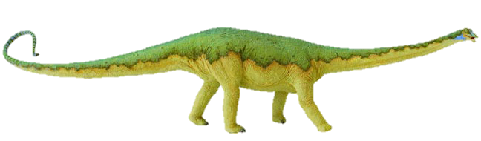
Long Short Vowel word sort
using phase 2-4 phonemes
Cut this top row off before you give the sort to pupils!

long vowel |  | 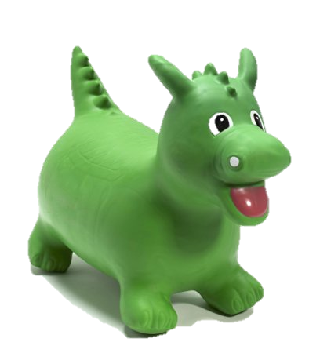  short  vowel
So many of the spelling patterns from Y1 onwards rely on the children being able to identify long and short vowel sounds. It’s worth really spending time on this.
Sometimes it’s helpful to say that short sounds are short and bouncy, and to make a bouncing ball action as you say them; while long sounds can be stretched, exaggerating the sound slightly, whilst making a stretching elastic kind of movement.
cat | snail | neck
leek | car | fork
cow | fool | coin
boat | fear | chair
pot | peck | tug
tin | light | fill
can | pin | hop
peg | bun | rain
seek | night | goat
took | mark | corn
curl | crown | moist
tear | fair | pure
hat | pan | still
pit | pen | got
shed | this | stuck

